Class Exercise - SRS
Use Case Diagram for ATM

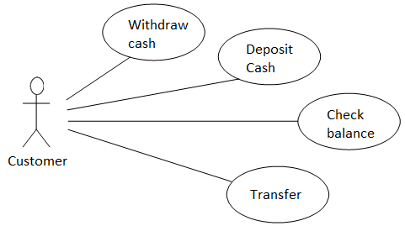

Use Case for ___Withdraw cash________________
Use Case Name | Withdraw cash
Trigger | When users are successfully authenticated in the app and click on the withdraw cash button.
Precondition | - Users must have bank account  - ATM system and user’s bank account are operational  - Users must successfully enter PIN.
Basic Path | - Customers insert their card into the ATM machine  - The machine requests to enter their valid PIN number  - The machine system validates the PIN  - If the PIN is validated successfully, users hit the “Withdraw cash” button  - The system prompts the amount of withdraw cash  - The system verifies the account balance  - If the account balance is sufficient, the machine dispenses the requested amount of cash  - The customer’s bank account will be deducted with the following requested amount.  - The system displays the confirm message  - The machine returns the card.
Alternative Paths
Postcondition | - The cash is dispensed to the customer  - The amount of account balance is updated  - The machine will log the transaction record to the bank system
Exception Paths | - If user enter the invalid PIN  - The system displays unsuccessful message  - F  - The bank account balance is insufficient  - The system will ask the adjust the requested withdraw money or cancel the transaction.
Other

Class Exercise - SRS
Use Case Diagram for ATM

Use Case for ___Deposit cash________________
Use Case Name | Deposit cash
Initiating Actor
Actor’s Goal
Participating actor

Preconditions
Flow of events
Postconditions
Other

